

ASSIGNED BY:
Muztabir Bakhtear 1931562030
Maisha Mahzabeen Zaara 2122028630
Md. Mahedi Hassan Saad 2011752030
Mollick Muhibullah Afsari 2011611630

Section-01
MIS470: System Analysis & Design
SPRING-2025

ASSIGNED TO:
Dr. Md. Shamim Talukder
Assistant Professor, Department of Management
North South University
Letter of Transmittal

21st April 2025

To,
Dr. Md. Shamim Talukder
Assistant Professor, Department of Management,
School of Business and Economics,
North South University

Subject: Requesting to accept the submission of the Project on "M/S Poultry Feed & Medicine"

Dear Sir,
We are writing to formally submit our project report on "M/S Poultry Feed & Medicine." We have dedicated significant time and effort to researching and preparing this report according to the course materials and your guidance.
We hope that this report meets all the requirements for the project. We sincerely appreciate the opportunity to work on this project and gain valuable experience under your guidance.
Thank you for your continued support and mentorship throughout this academic journey.

Executive Summary

Table of Contents
ASSIGNED BY: 1
Introduction 5
Functions of the Firm 5
Manual Record Keeping 5
Financial Statement Analysis 5
Lack of Employee Management System 5
No Online Platform for Customer Interaction 5
Problems & Proposed Solutions 6
Problems related to business functions 6
Proposed Solutions to the Problems 6
Chosen Problem & Solution 7
SDLC 8
System Planning & Selection: 8

Introduction


We are specialized and dedicated to providing quality feed, chicks, and medicines for the agricultural and livestock sector, such as Munshiganj Poultry Feed, Chicks, and Medicine, a local enterprise. Led by renowned companies including CP, Renata, and Square, the firm is crucial in its role in maintaining the local farming ecosystem via the sourcing of reliable and trusted product offerings. Munshiganj Poultry is positioned as a B2B provider, providing its services to the farmers and shopkeepers by helping them get access to the essential livestock supplies easily.

The business operates within a value chain comprising the purchasing of feed and livestock, distributing credit to the farmers, and selling to the retailers. Doing that helps farmers raise poultry without encumbering the firm immediately with financial resources and without reaching a fair return through a systematic process. Despite a solid operational base, the firm has not yet overcome important barriers to scale that are fixed in its internal systems and a lack of digital presence.

Functions of the Firm
A few Core Business Functions of Munshiganj Poultry Feed, Chicks, and Medicine that support the process of operation and service delivery are investigated. Nevertheless, most of the functions in today’s office are being managed manually, resulting in inefficiencies that affect growth and sustainability.

Manual Record Keeping
The company does not have an electronic system for data collection, nor do they possess an electronic system for bookkeeping. Therefore, the situation of data duplication and potential inaccuracies exists. The excessively small-scale credit transactions cause the accountants to record unnecessary entries repeatedly, which hampers oversight.

Financial Statement Analysis
Since there is no automated financial system, the company cannot create a report or monitor its financial health. It blocks any decision-making, and management does not have visibility on profitability, cost, and business performance.

Lack of Employee Management System
There is no employee performance system, attendance or productivity system, with 17 employees in a small team. This reduces the ability of management to assess and improve workforce efficiency.

No Online Platform for Customer Interaction
There is no online presence, so customers have difficulties accessing product details such as pricing, availability, and market trends. The digital communication gap leads to decreased customer satisfaction and the limitation of potential sales.
Since the firm suffers from these operational weaknesses, it needs to implement technological solutions such as inventory automation and then ERP system. Additionally, a platform that enhances customer engagement and smoothens sales processes will need to be set up in an online space.

Problems & Proposed Solutions

Problems related to business functions
Time Management: The business spends excessive time on manual data entry, customer follow-ups, and order processing. Employees manually track inventory, sales, and customer details, wasting time and causing inefficiency.
Errors: Manual data entry leads to errors in inventory, orders, and customer information. For example, human mistakes in stock counts or order processing often result in dissatisfied customers and lost revenue.
Lack of Integration: Different parts of the business operate in silos (e.g., sales, customer service, inventory). This lack of integration makes getting a real-time overview of operations difficult, leading to miscommunication and inefficiency.
Inventory Management: Inventory management is done manually or using outdated methods. This causes stockouts, overstocking, or inaccurate product availability tracking, leading to lost sales and customer dissatisfaction.

Proposed Solutions to the Problems
Time Management Solution: We have bought and implemented a Customer Relationship Management (CRM) system that automates customer data entry, order tracking, and communications. This has reduced the time spent on manual tasks and improved workflow efficiency.
Error Solution: We have bought an Inventory Management System (IMS) that automates stock tracking, order fulfillment, and data entry. This system ensures that stock levels are always accurate, reducing human errors.
Lack of Integration Solution: We have integrated a **cloud-based business management platform** that connects sales, inventory, and customer service. This platform ensures seamless data flow across all departments, reducing miscommunication and improving operational efficiency.
Inventory Management Solution: We have implemented a Barcode/RFID-based tracking system to automate inventory management. This system ensures real-time stock level updates and reduces human stock count errors.


Chosen Problem & Solution
Inventory Management: This is one of the most critical areas that affect sales, customer satisfaction, and overall business efficiency. Inaccurate stock levels lead to stockouts or overstocking, causing financial loss.
Inventory Management System (IMS) Implementing this solution has significantly improved our stock tracking, minimized human error, and automated several manual processes, enabling real-time inventory visibility. This system helps ensure we never run out of stock or overstock, leading to cost savings and improved customer satisfaction.
-Efficient: Automating the inventory process saves time and reduces errors in order fulfillment.
-Customer Satisfaction: By ensuring the right products are available at the right time, we can fulfill customer orders more accurately.
-Cost Savings: By optimizing stock levels and reducing stock, we can reduce unnecessary inventory costs and lost sales.
After evaluating all the problems and solutions, we have decided to focus on the Inventory Management System (IMS). This solution directly impacts our efficiency, reduces errors, and improves our ability to serve customers with accurate and timely stock information. As a result, it is the top priority for implementation moving forward.

Planning of The System

SDLC

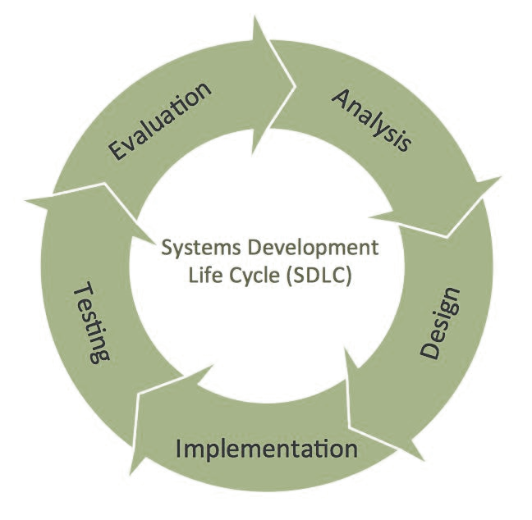
System Planning & Selection:
Goal: To develop an automated & digital sales system.
Objectives:
- Identify key problems and other opportunities for improvement in digital transformation.
- Feasibility Study, such as risk, cost & benefit analysis.
- System Analysis:
To understand the present business process and collect all the system requirements.
Activities:
- Interview all the employees, buyers, partnered farmers, and shopkeepers.
- Will document all the manual workflow, such as inventory tracking, bookkeeping, credit transactions, etc.
- Expected system requirements: Real-time inventory management, automated financial reporting, employee attendance and productivity tracking, and customer web portal.
- System Design
To design the system, we will create blueprints for the system.
Logical Design: Design process flows such as 1) order → 2) invoice → 3) delivery → 4) payment.
Physical Design: We will design the system for a web-based ERP that is mobile-friendly and includes tables for inventory, employees, credit history, and customers.
Also, we’ll use project management to keep track of our project cost and schedule.
- System Implementation & Operation:
- We will develop the ERP system by integrating it with the existing one.
- Migrate existing records into the system.
- We’ll train all employees in system usage.
- Launch online portal for customers to check product info and prices.
- Implement inventory automation and real-time updates.
- Evaluation & maintenance:
Ensuring the system runs effectively and remains up to date.
- Identify and fix those bugs & patch issues.
- Regularly update the system for new business requirements.
- To evaluate, we will monitor system usage, employee productivity, and customer feedback.

Managing Project

Activity Table
Activity | Name | Duration | Predecessors
1 | Project Meeting | 0.2 weeks
2 | Requirements Gathering | 1 weeks | 1
3 | Develop Project Scope Document | 0.3 weeks | 2
4 | Information Architecture | 2 weeks | 3
5 | User Interface (UI) Design | 2 weeks | 4
6 | Develop Database | 2 weeks | 5
7 | Frontend Development | 4 weeks | 5
8 | Backend Development | 4 weeks | 6
9 | Security Testing | 1 weeks | 7,8
10 | Functionality Testing | 2 weeks | 9
11 | System Installation | 2 weeks | 10
12 | Website Launch | 1 weeks | 11
13 | Documentation | 1 weeks | 12
14 | Performance Monitoring | 3.93 weeks | 12
15 | Website Maintenance & Bug Fixes | 2 weeks | 12

Network Diagram

Critical Path
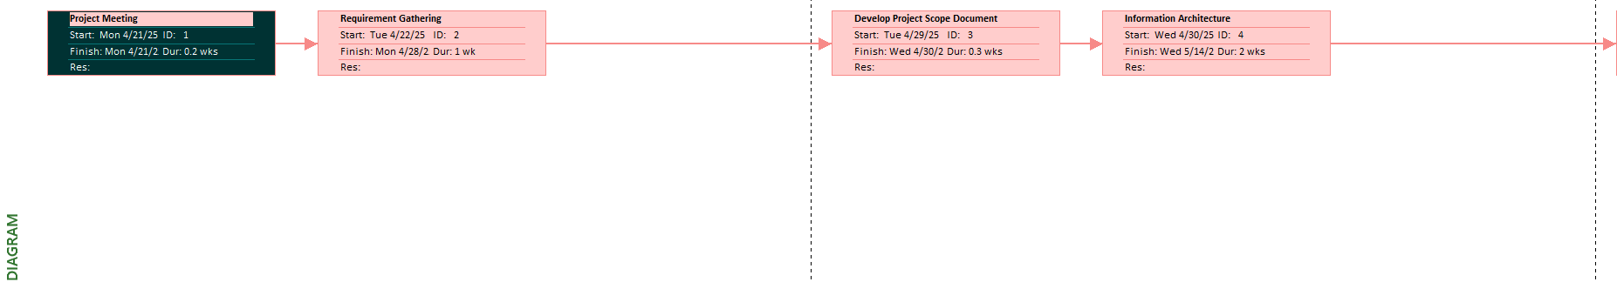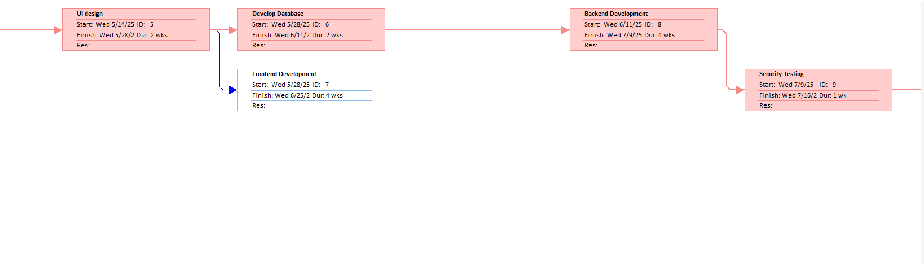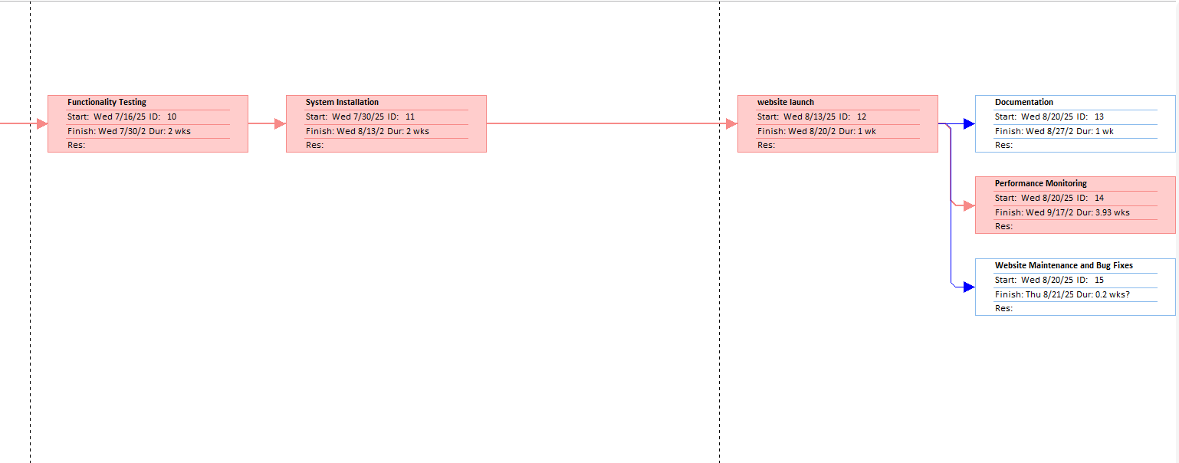

GANTT Chart
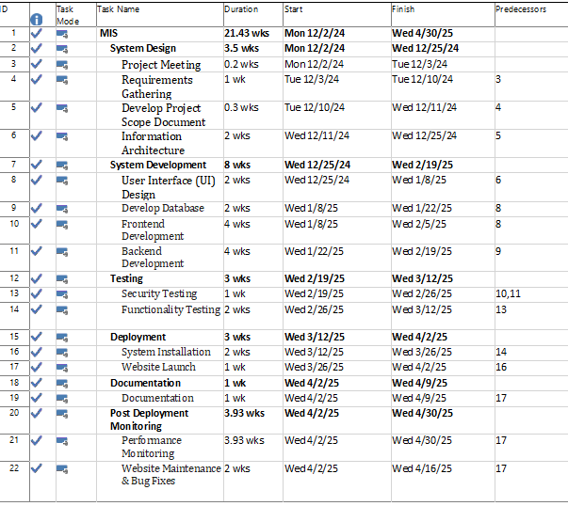

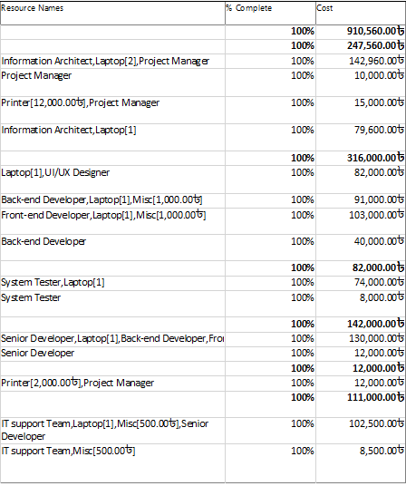

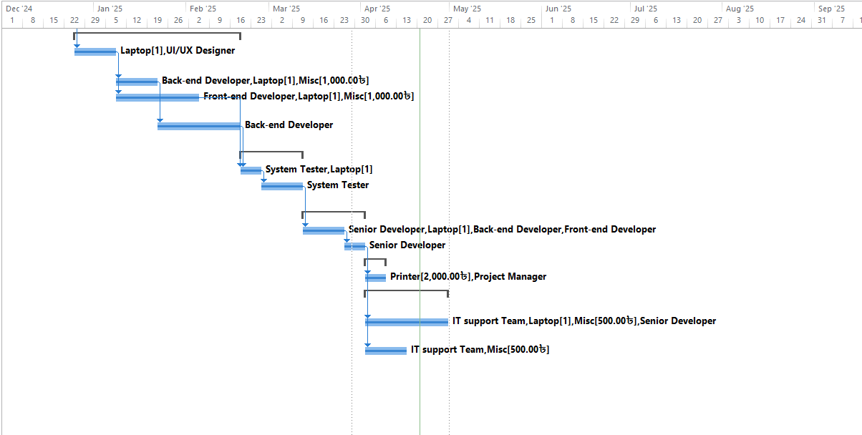

PERT Chart
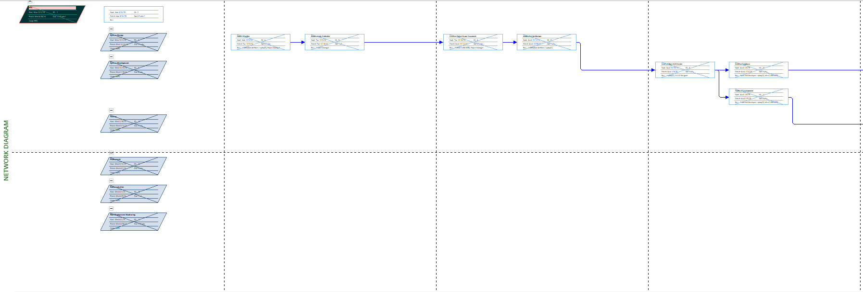
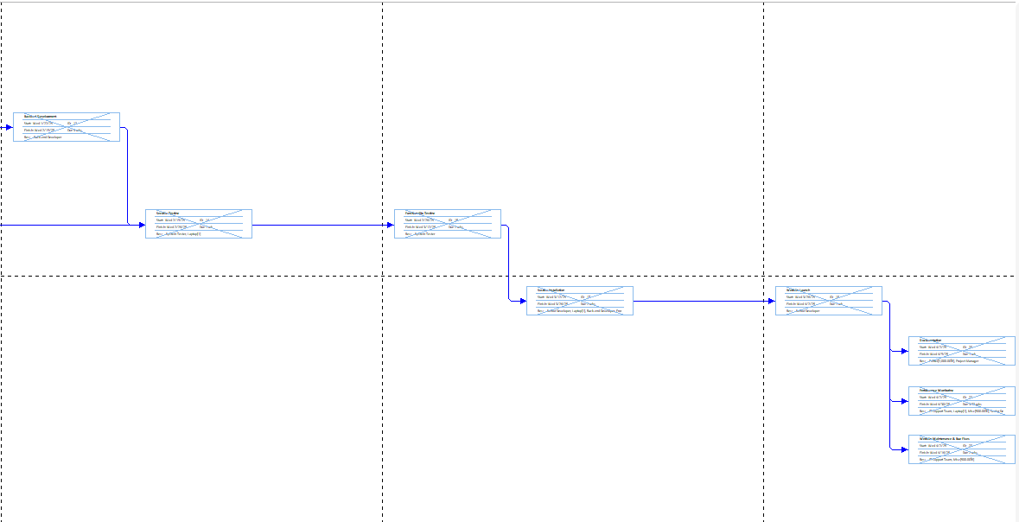

Resource Sheet
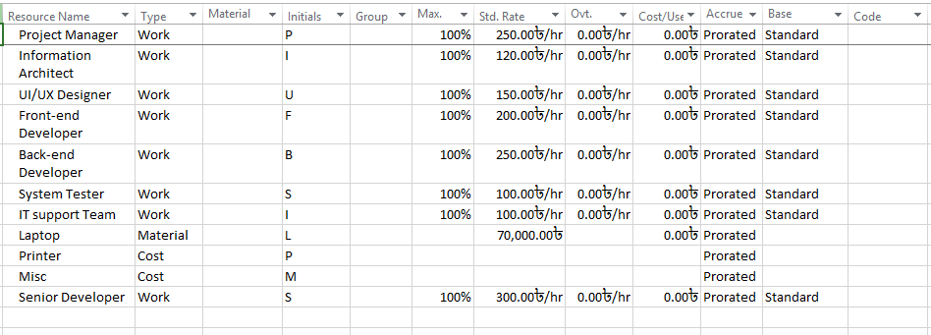

Reports Overview
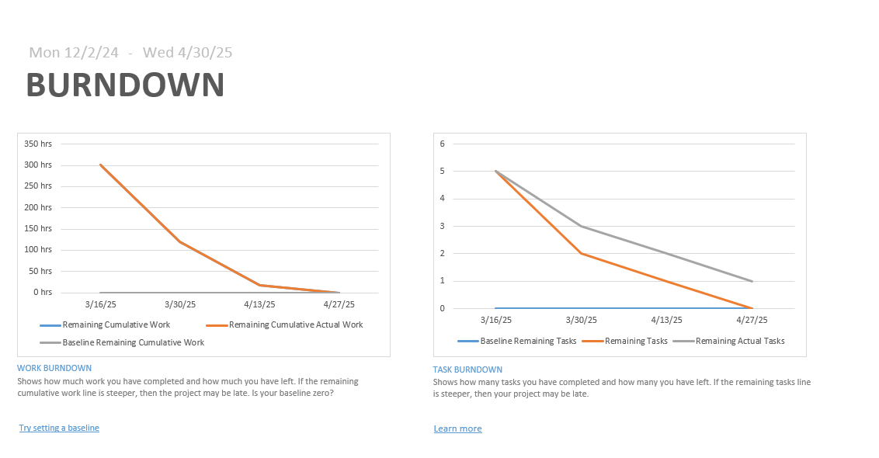
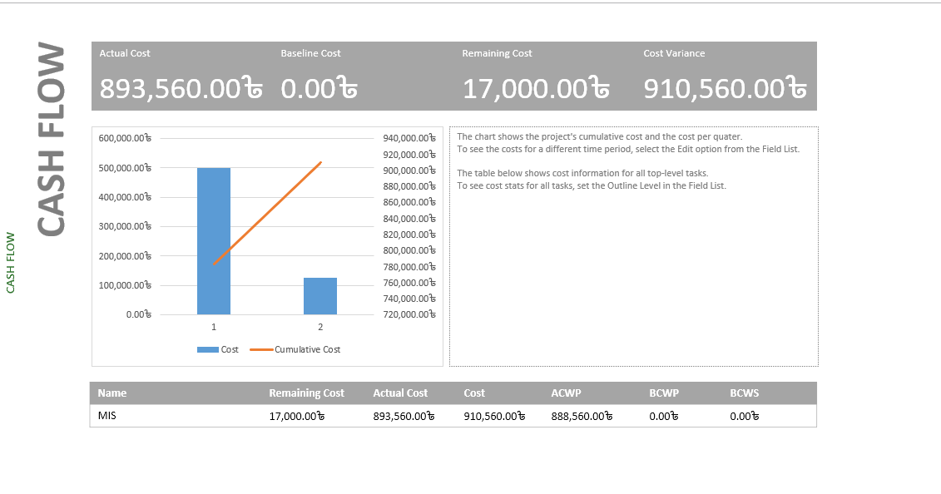

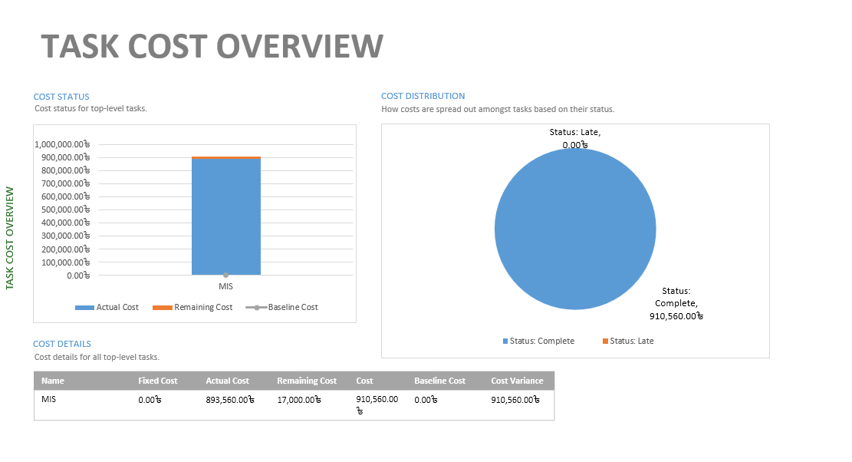
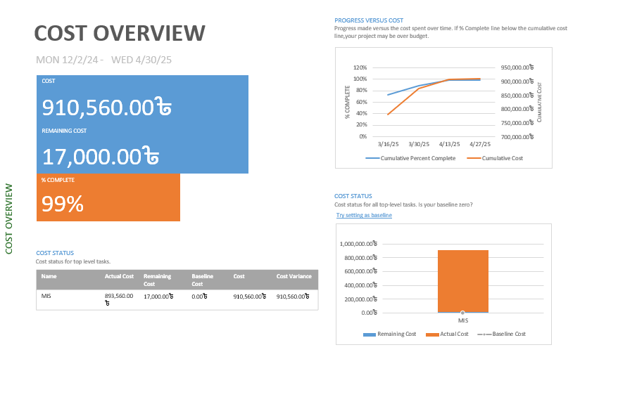

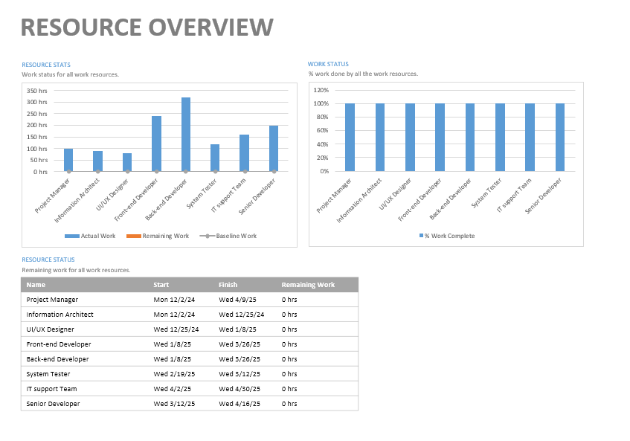
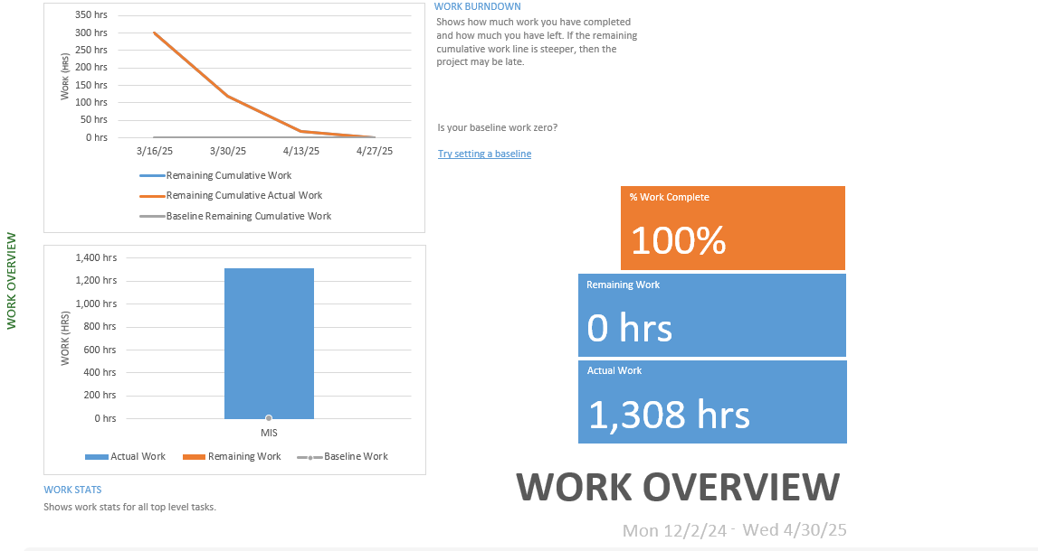

Feasibility Study for Munshiganj Poultry Feed & Medicine

1. Economic Feasibility
Munshiganj Poultry Feed, Chicks and Medicine operates its current business processes using manual systems that produce inefficiency as well as elevated operational expenditures. An automated platform will lower operation costs while simultaneously increasing productivity to support business deals through an easier transaction system. The website offers enhanced inventory management capabilities, together with improved sales productivity, which leads to higher customer satisfaction. The establishment of an online ordering platform and automated process will enable the company to attract more customers while raising its revenue and profit levels.
The required budget for website development, along with startup costs, amounts to 350,000 Takas.
Benefits:
- Reduced human error in inventory management.
- Customers will achieve more readily accessible product ordering in addition to simpler purchasing procedures.
- Improved customer retention through better service.
- Higher revenue due to better business reach (national and international).

2. Technical Feasibility
The smooth operation of the new website will demand various advanced technologies since it constitutes a complicated system. The website establishes an electronic marketplace that enables customers to buy poultry feed together with chicks and medicines. A backend integration with the company's inventory management system, together with a user-friendly, mobile-accessible front-end, constitutes the website requirements.
Technologies Required:

- Backend: PHP with Laravel or Django framework for scalable development.
- Frontend: HTML, CSS, JavaScript for responsive design.
- The application manages product information through MySQL or PostgreSQL database engines.
- Payment Gateway Integration: Secure online payment methods such as bKash or Credit/Debit Cards.

3. Operational Feasibility
The current operational structure of Munshiganj Poultry Feed, Chicks, and Medicine depends on offline transactions and traditional inventory management practices, causing delays in service delivery. The company will achieve operational simplification through website implementation because it will automate order handling, combined with real-time inventory management capabilities.
Improvements:

- The website will unite inventory tracking functions to eliminate manual data recording requirements.
- Through automation, the platform will provide quick customer service by managing queries and tracking orders until completion.
- The system enables continuous business operations, which eliminate time constraints and allow the company to function beyond routine hours.

4. Schedule Feasibility
The development process will occur through different stages, which will address each important aspect of the business operation. The development timeline spans twenty weeks, totaling 140 days.
Development Timeline: 20 weeks or 140 days.
The first phase, consisting of planning and design scheduling, requires four weeks to complete.
- Phase 2 (Backend Development): 6 weeks.
- Phase 3 (Frontend Development): 6 weeks.
The testing phase and implementation period together require 4 weeks.
We will launch the system after 20 weeks of development, which does not include official holidays. The schedule indicates that project completion will happen as planned, with established checkpoints and review sessions.

5. Legal and Contractual Feasibility
As Munshiganj Poultry Feed, Chicks, and Medicine operates as a locally based business with a non-governmental project, there exist minimal legal restrictions blocking website implementation. However, legal considerations will include:
All website design elements, along with content, will operate under copyright protection.
The company upholds local data protection regulations which apply to payments as well as other customer information.
The project team will acquire the licenses needed to operate third-party software elements.
The development of the website will not encounter significant legal restrictions provided standard legal operations are properly executed.

6. Political Feasibility
As a private effort of Munshiganj Poultry Feed Chicks and Medicine, the website development project will not involve any political hurdles. The project stands independently, and the company is its primary implementer, as it maintains no connection with government agencies. After development completion, the project will transfer to Munshiganj Poultry Feed Chicks and Medicine as the project owner, while political involvement remains out of the picture.

Resource Requirements
Functional Resources:
The website needs an online payment gateway that provides customers with secure transactions when buying feed, chicks, and medicines through the system.
The system implements a Database Management System for storing customer data, order records, and product information.
The website requires servers along with hosting services to operate the database management system through hardware.
IDEs, version control systems, and testing platforms belong to the list of development tools.

Non-functional Resources:
Authentication: Secure login for customers and internal staff for order management and system access.
The website design includes the ability to grow with additional customer volume and bigger product catalogs that the company plans to develop.
The website will function optimally to ensure swift loading times coupled with an easy-to-use experience.
• Security: Strong encryption for the payment gateway and customer data protection.
• Usability: Simple, user-friendly interface for easy navigation, particularly for farmers and retailers.

System Design

Process Modeling (DFD)
- DFD- Level 0
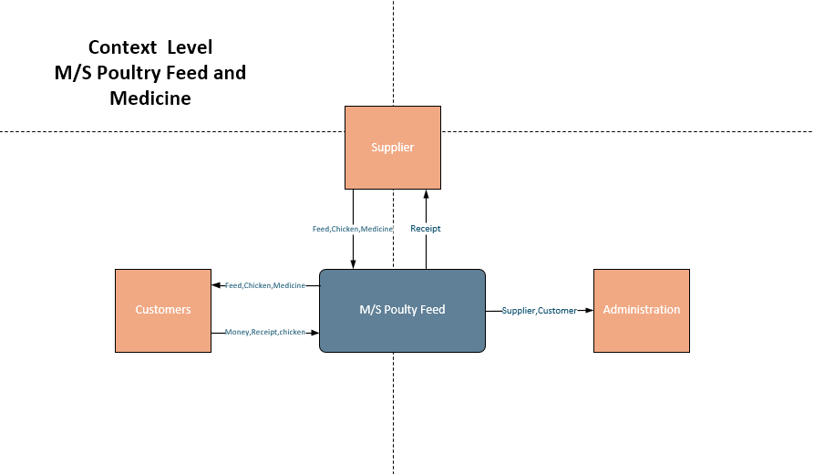
- DFD- Level 1
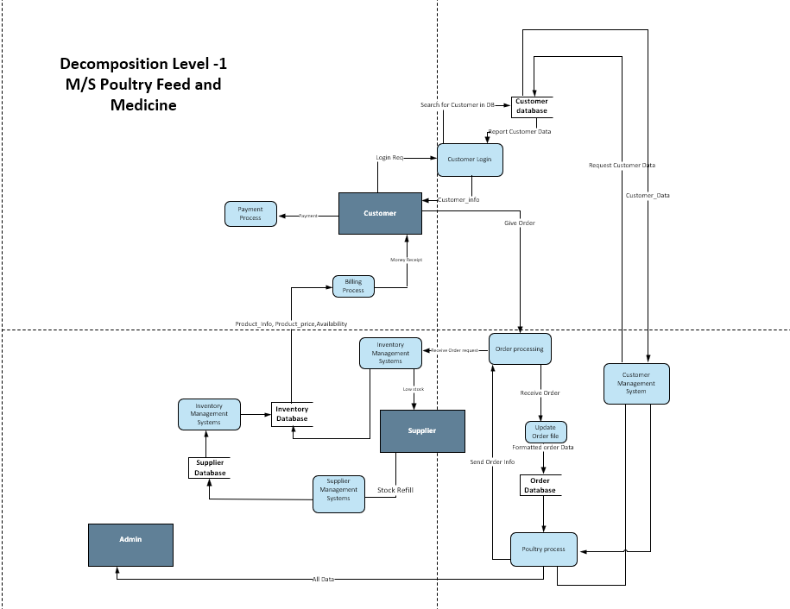

Data Modeling (ERD)
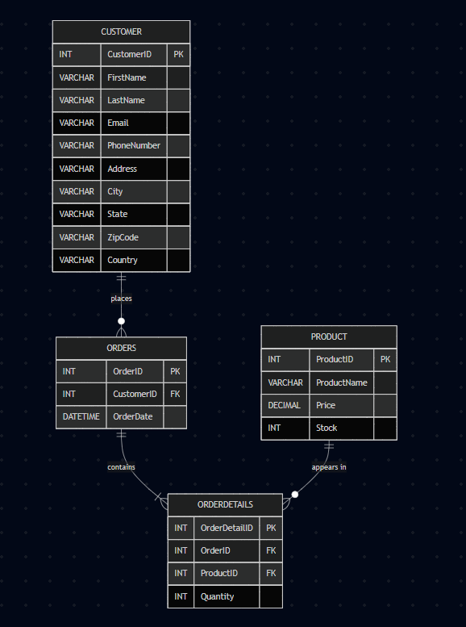

Human/User Interface Design



Dialogue Design
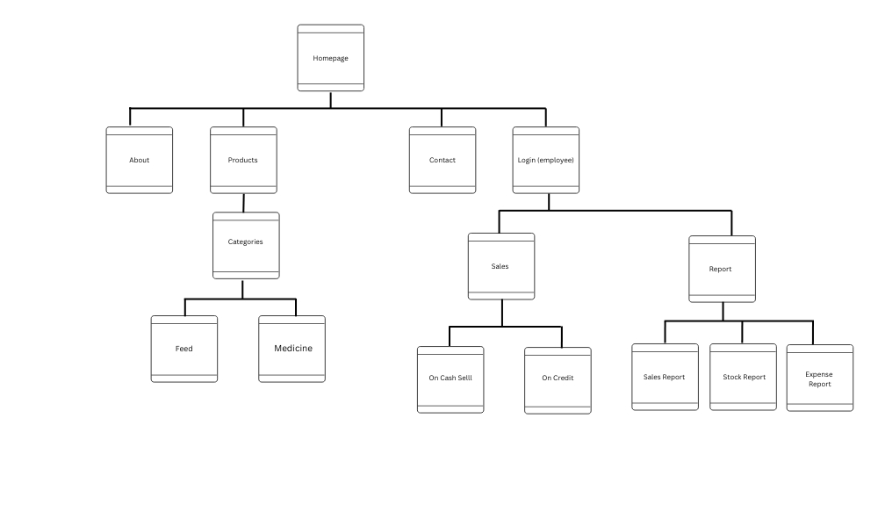

System Development
MySQL
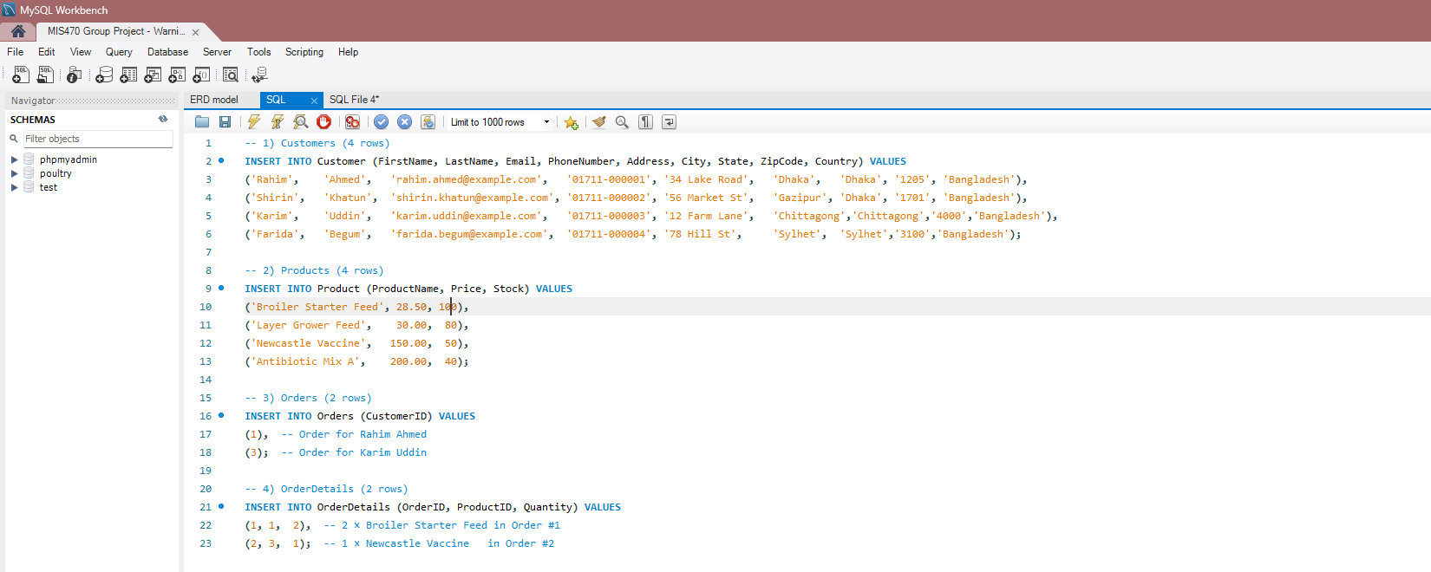

PHP Admin
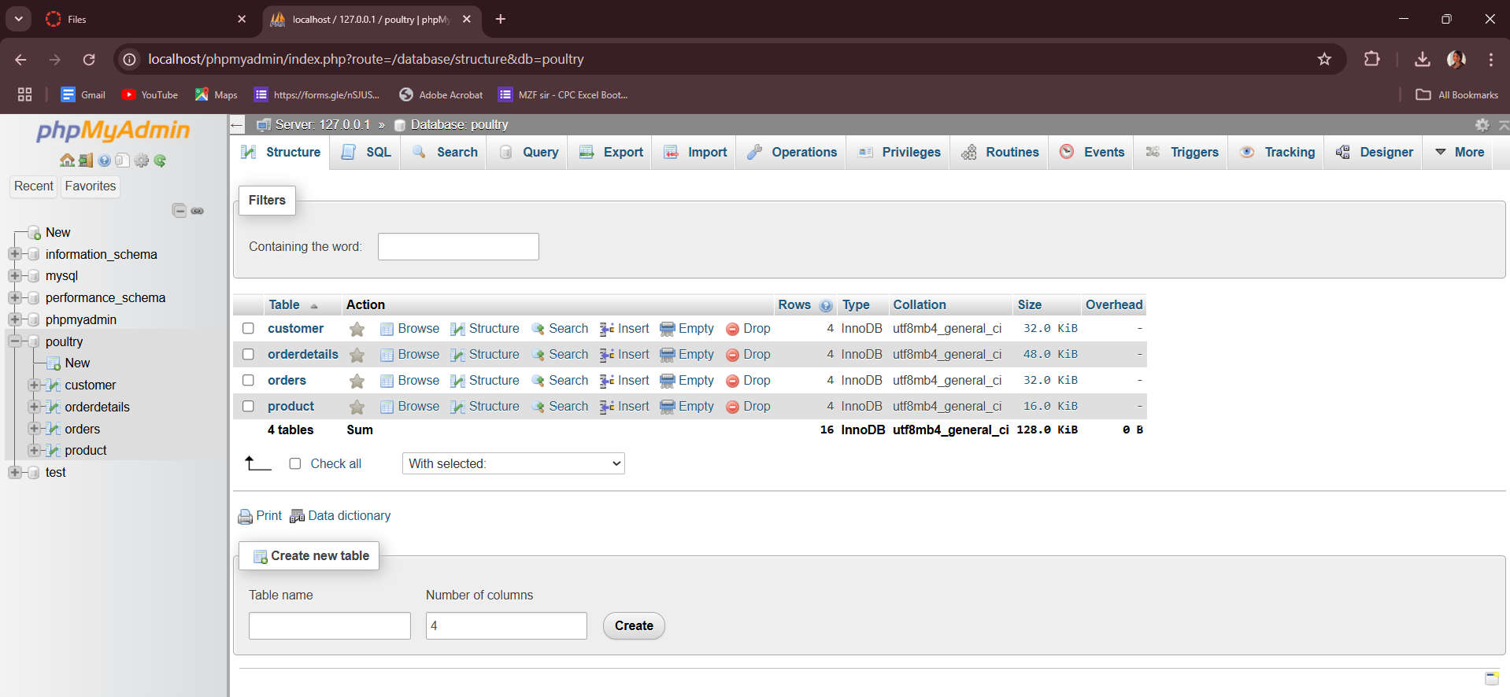

VS Code
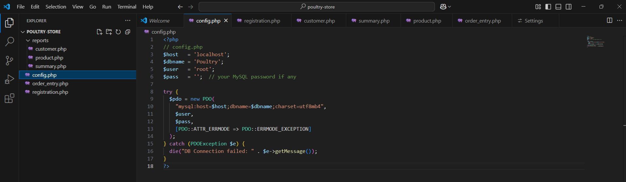
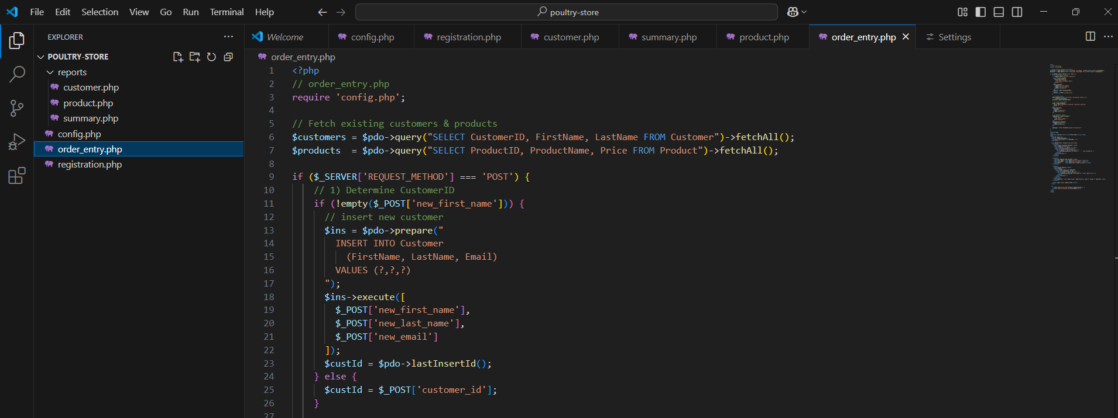

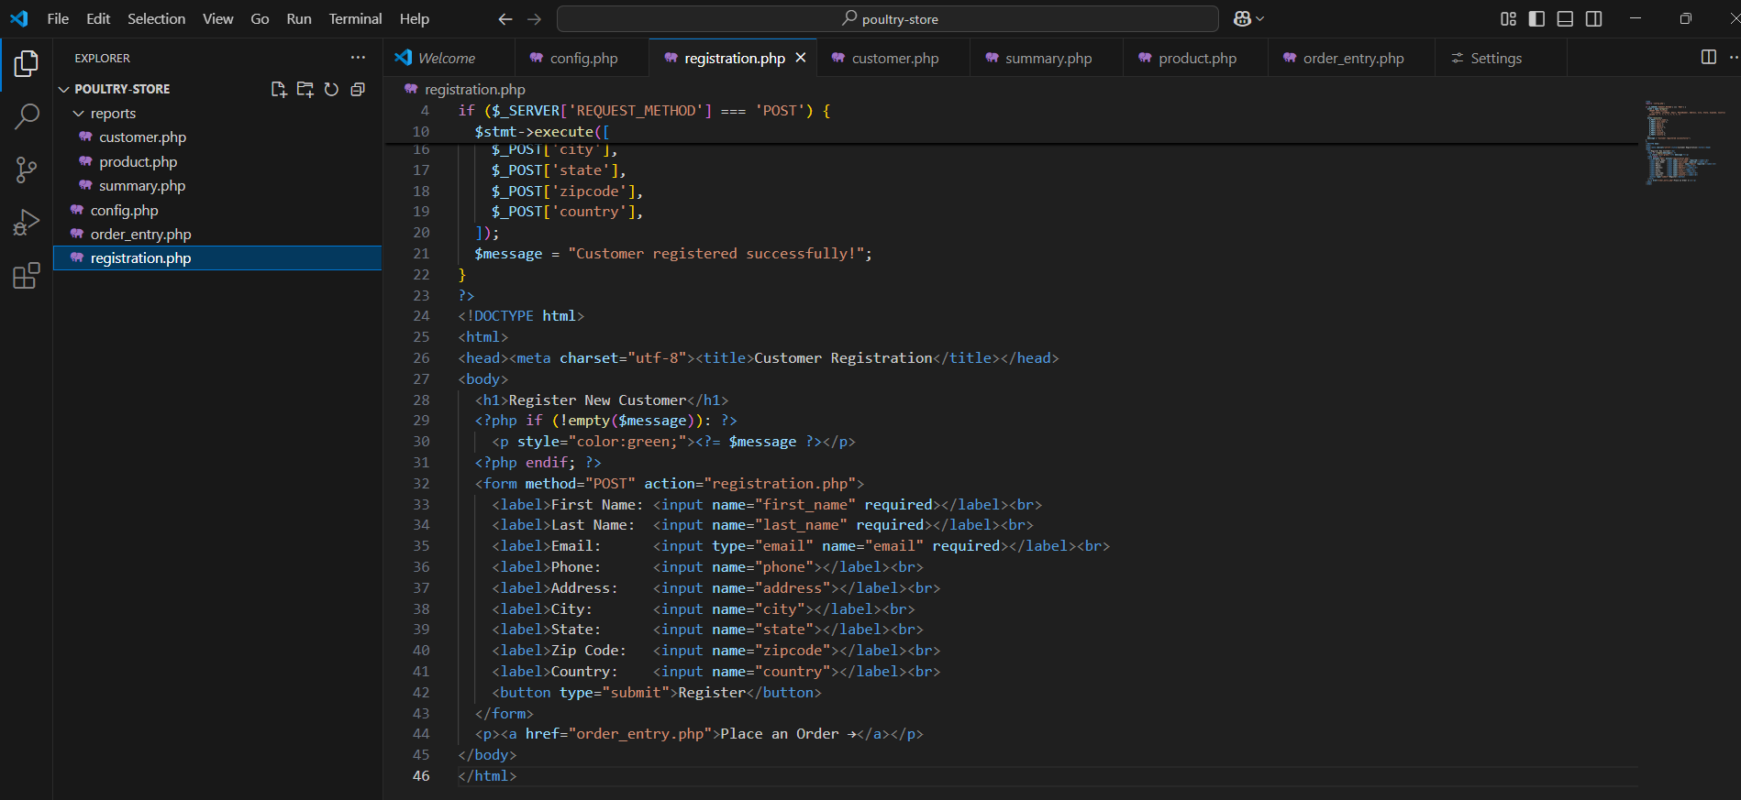
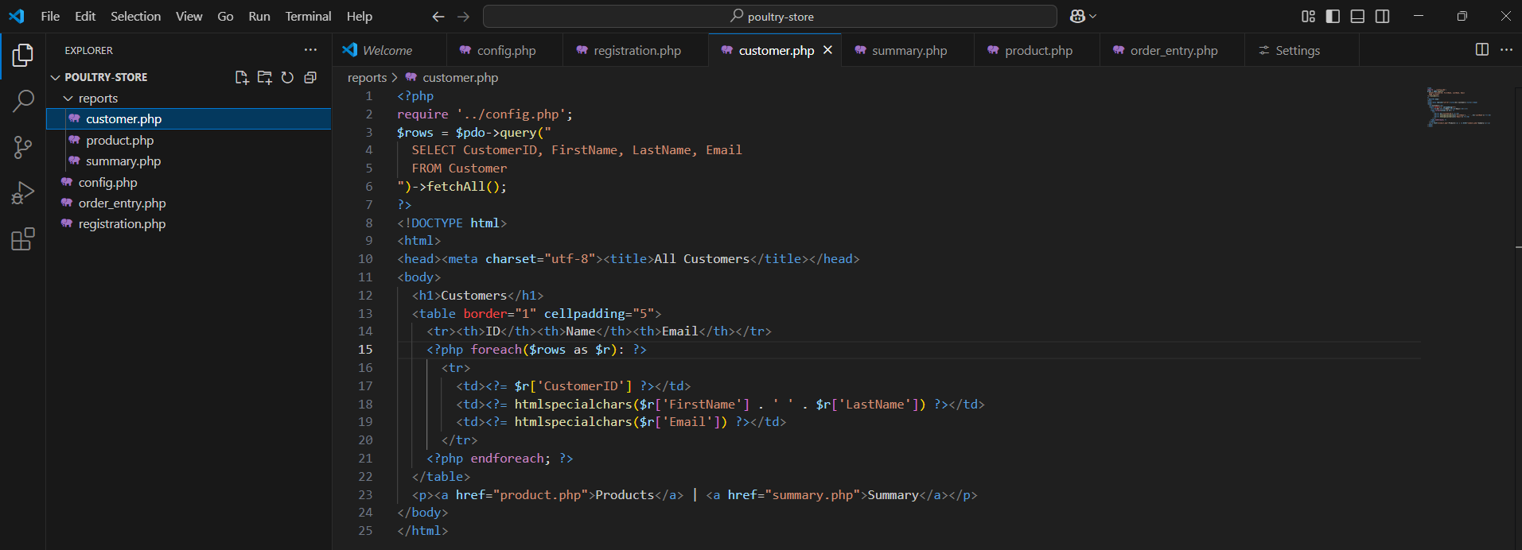
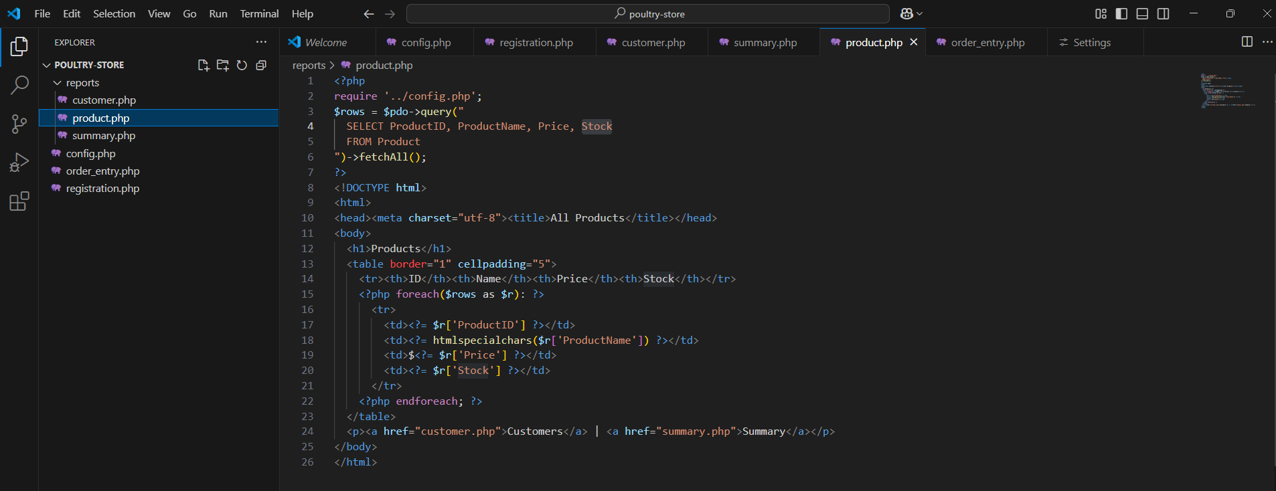

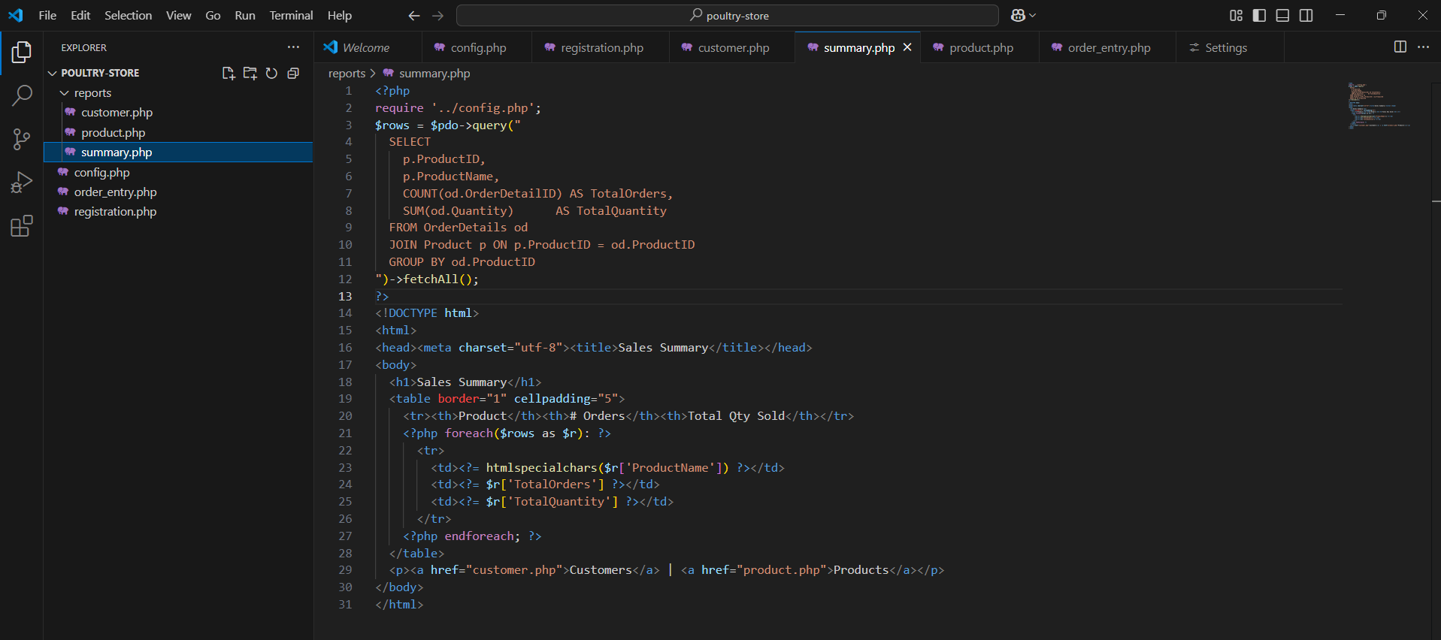

Systems Implementation and Operation

Coding
We will use PHP as our server-side programming language in developing the system backbone because PHP represents a versatile option for server-side development. Itxdesign.com explains that PHP delivers high-performance speeds at minimal complexity levels that benefit shared hosting environments and related domains. PHP exists as a preferred language for building different systems, such as e-commerce solutions, combined with material management programs, website development systems, and online applications.
Development of the user interface will use HTML together with CSS alongside JavaScript. Websites require the HTML markup language for their creation (Chris 2021). The site's design will depend on CSS, while JavaScript will serve to make the site interactive through dynamic features. The system requires these technologies to provide farmers, dealers, and employees with a spontaneous and user-friendly experience during their system interactions.
Testing
A system implementation process requires tests as an essential measurement procedure. Testing mistakes during long-term implementation will create multiple system issues, which will lead to errors. Testing occurs through these approaches:
- The first test phase will be the device test that examines each system component to detect potential system error points.
- During the integration phase, we conduct tests to determine how independent units connect with others and whether they operate properly with integrated systems and throughout exchange processes.
- We will perform system testing of integrated devices working as units to locate any detected system errors.
- After the acceptance test process, proceed with the approval test to confirm that system requirements are achieved.
- The system will undergo testing under stressful conditions using replicating loads, data, and security protocols. The system will perform stress testing together with safety tests to detect systematic faults.
- A beta test follows alpha testing protocols, which utilize genuine landscape and historical data to verify system functionality. This process determines if the system operates adequately.

Installation
- An information system handles operations in Munshiganj poultry feeds, chickens, and medicine. The dual implementation of the new system with the existing system runs simultaneously. Supervision of all operations involving poultry feed and chickens, together with drugs and distribution, will become unified under one integrated system.
Documentation
Business documentation related to system development will undergo update procedures at each stage of the devotional process. Following installation, external documents will be developed for performance evaluation with structured charts and additional relevant data.
Training
The system development company will train a group of our staff members to operate the system in its initial stage. System developers, together with our staff, will use interactive manuals along with video training to teach employees who will lead the operational training of other staff members.
Support
The customer service agents from our organization will function as system support personnel while also serving as our regular employees who operate through the call center. The devices establish better systematized order management for both vendors and customers to resolve potentially occurring problems effectively.
Maintenance
Our maintenance strategy, based on prototypes, aims to react to changes within poultry farming through a continual addition of new characteristics that sustain system suitability with our suppliers and customers. The system operation will require constant maintenance through 24/7 monitoring of operations, combined with database adaptation and power and connection conservation to enable continuous work. The website needs regular maintenance for its operational continuity.
- This approach keeps the website content active and current with each update of the website and its resources.
- Security updates
- Regular data backups for websites.
- performance tracking; interface updates.
- Analytics tools like Google Analytics track user activity and website traffic.

Limitations
- Internet data constitutes the most important secondary information source in this report.
- The file contains cost and time-related projections that builders obtained through estimation and online research. System development cost and time-related information remained unknown to us since we operated by manual procedures.

